MY WORK EXPRESSION

* <https://my-work-expression.netlify.app/>

## TABLE OF CONTENT

### Project Info

### Design System

### Code and Framework

### SEO

### Accessibility (color)

### Deployment

### Performance

## Project Info

The aim of this project is to design, build and deploy a website which showcases my design and Front-End skills.

## Design System

The Design System is based on 3 main steps:

1. Wireframe Low Fidelity (Mobile and Desktop)

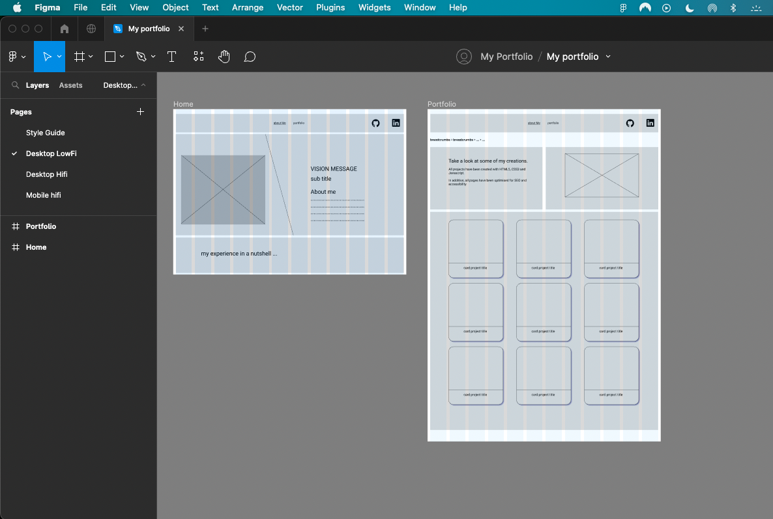

1. Color and Font Selection

1. Wireframe High Fidelity (Mobile and Desktop)

### Code and Framework used

My framework selection has been Bootstrap.

I have created 7 web pages, here is the sitemap:

### SEO

In order to boost SEO I have created:

* Meta tag Description
* Meta tag Keyword

In addition, to facilitate page indexing, I have added:

* Robots.txt file
* Sitemap.xml file

### ACCESSIBILITY

In terms of accessibility, I have used the following steps:

* Include an H1 per page

* Add an alt attribute per img tag
* Use the Picture tag to show a specific image according to the media used

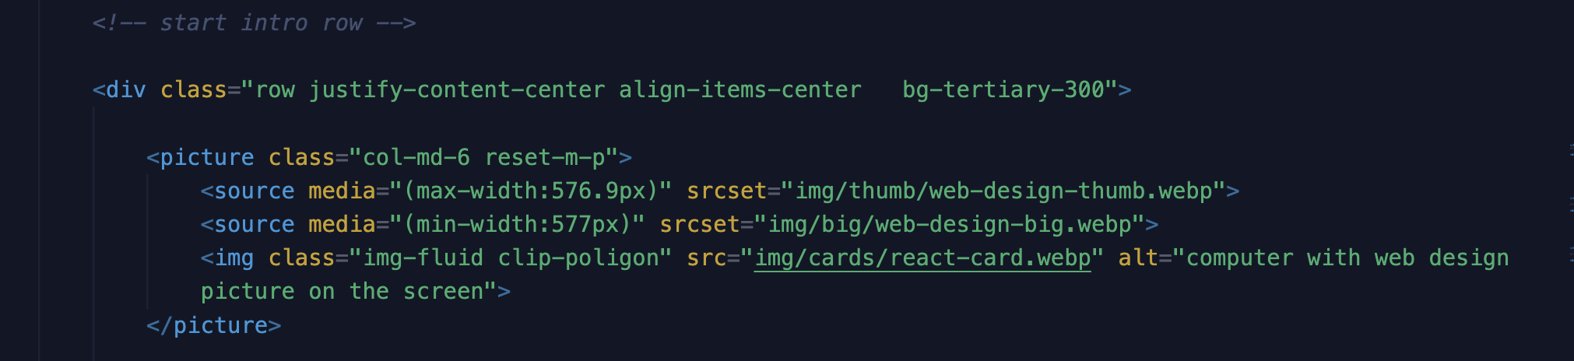

### DEPLOYMENT

The website has been deployed with Netlify.

This is the website address: <https://my-work-expression.netlify.app/>

### PERFORMANCE

To measure the website performance, I have used the Lighthouse plugin:

